**COMPUTER NETWORKS LAB**

**Understanding Persistent and Non-persistent HTTP Connections and Understand working of HTTP Headers**

**WEEK 4**

**NAME: VISHWA MEHUL MEHTA**

**SRN: PES2UG20CS389**

**SECTION: F**

**DATE: 12/02/2022**

**Task 1:**

**Objectives:**

To understand persistent and non-persistent HTTP connections and corresponding performance impact.

Create a web page with N (e.g. 10) embedded images. Each image should be of minimum 2MB size. Configure your browser (Firefox) with following settings (each setting requires  
repeat of experiment):

* Non persistent connection
* 2 persistent connections
* 4 persistent connections
* 6 persistent connections
* 8 persistent connections
* 10 persistent connections

Server:

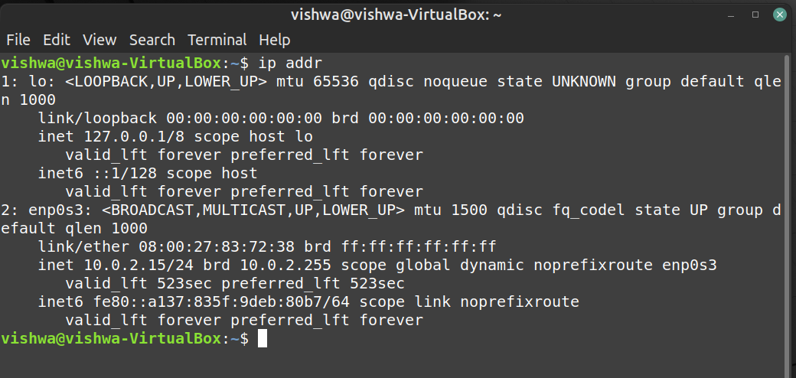

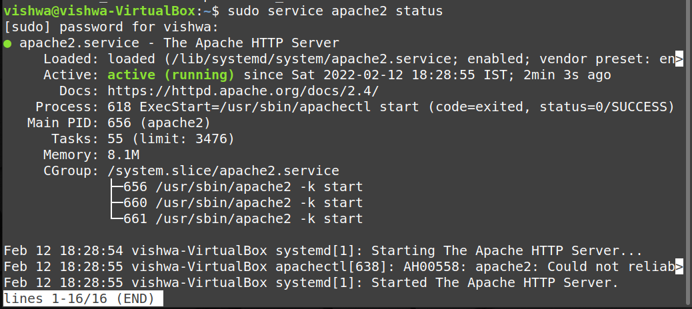

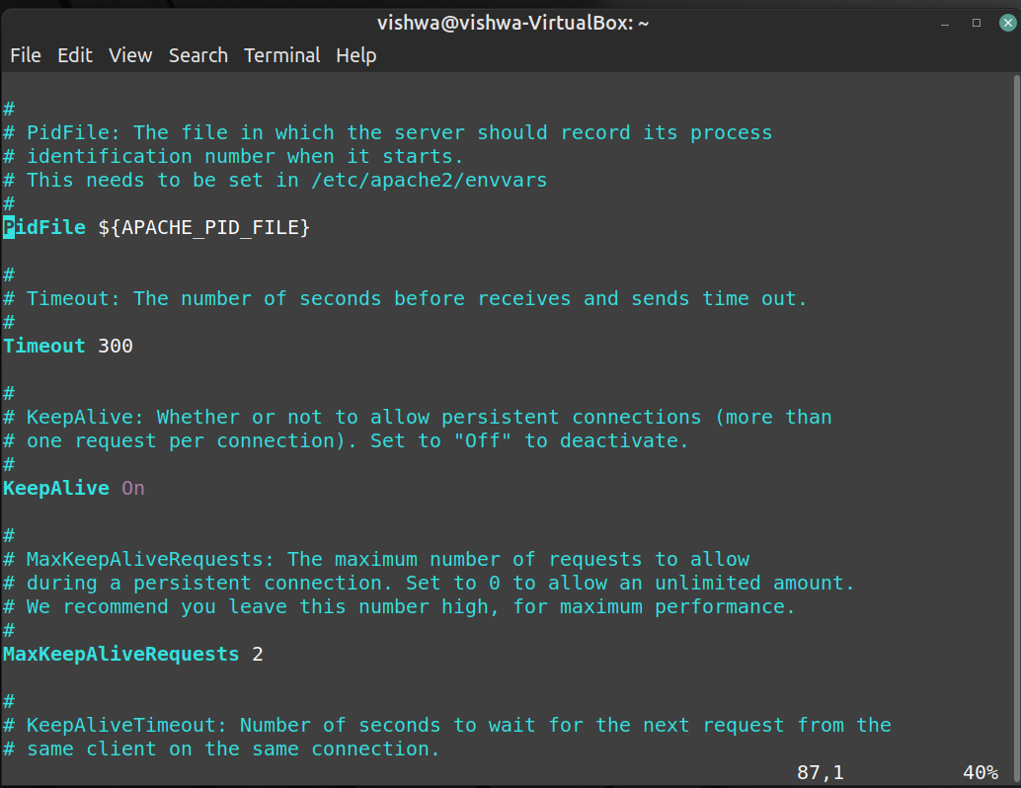

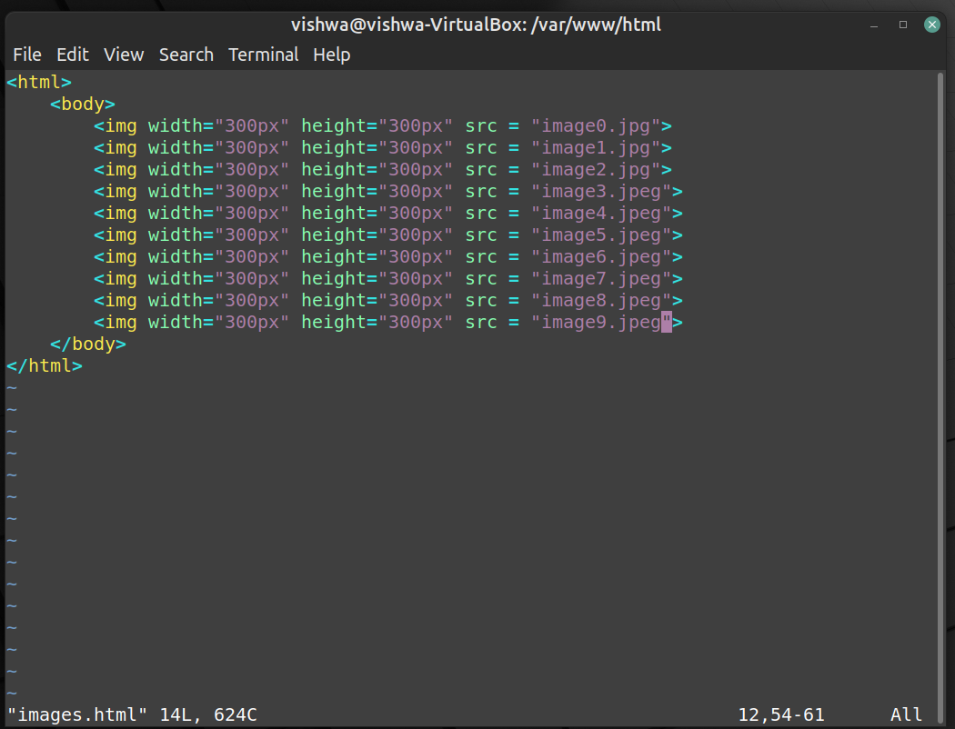

Client:

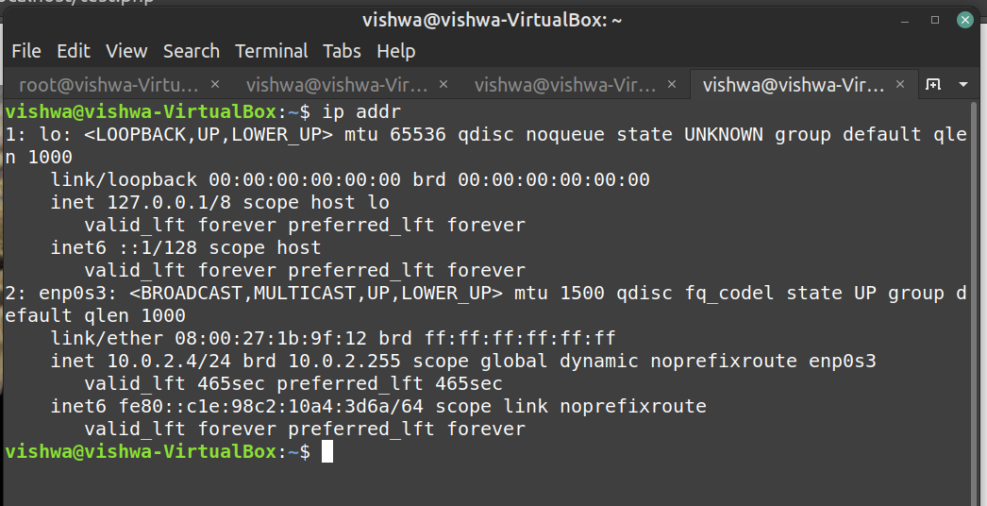



**OBSERVATIONS:**

a) Non-persistent connection:

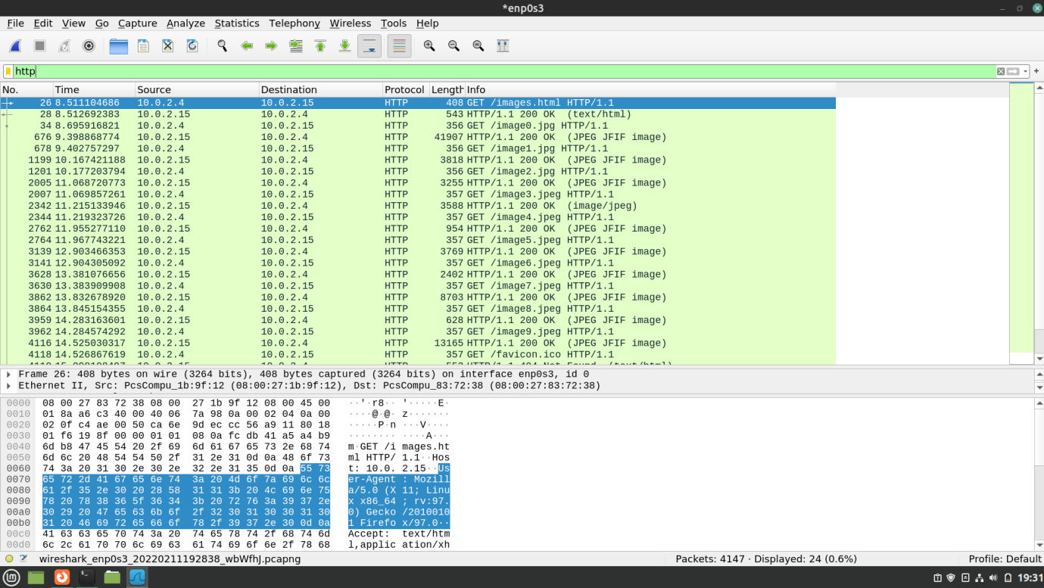

b) 2 persistent connections:

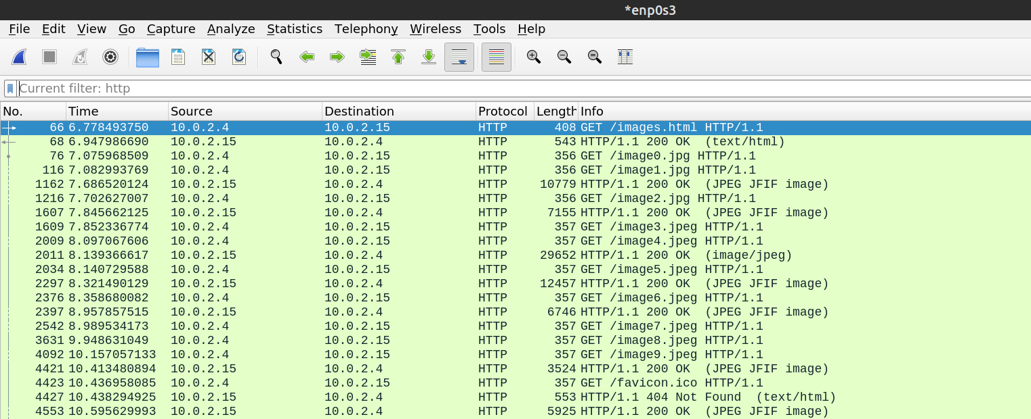

c) 4 persistent connections:

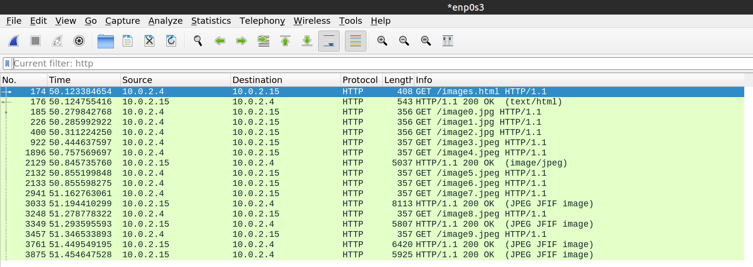

d) 6 persistent connections:

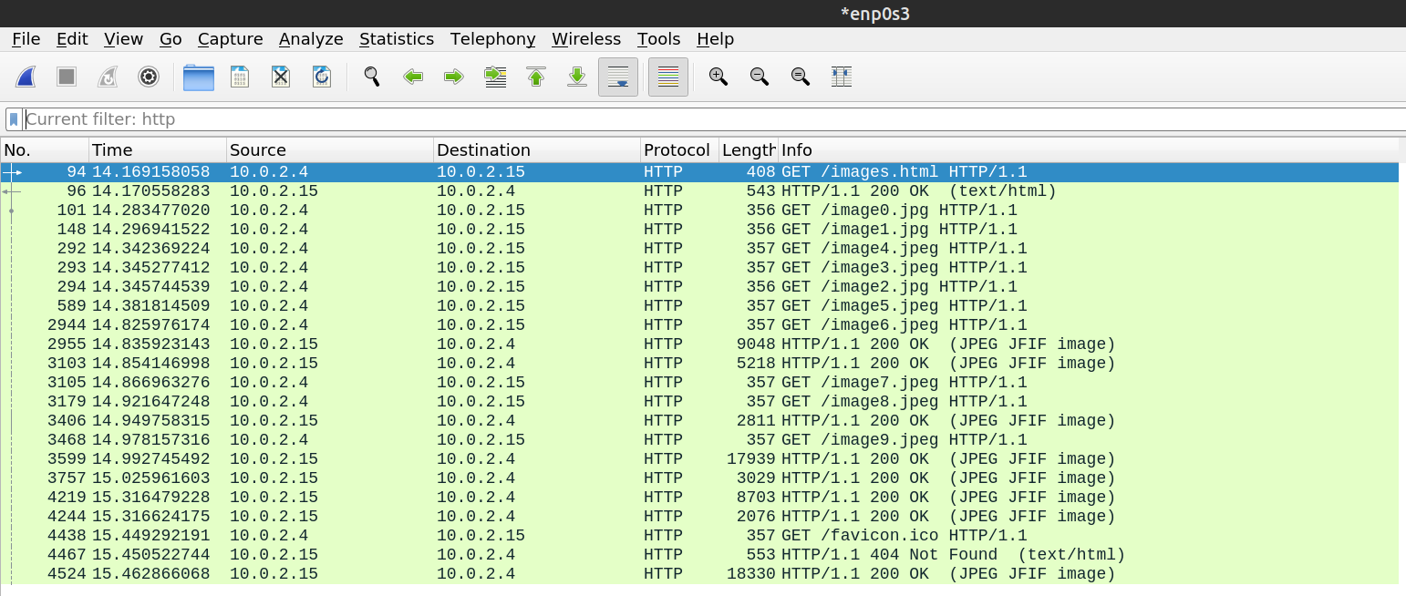

e) 8 persistent connections:

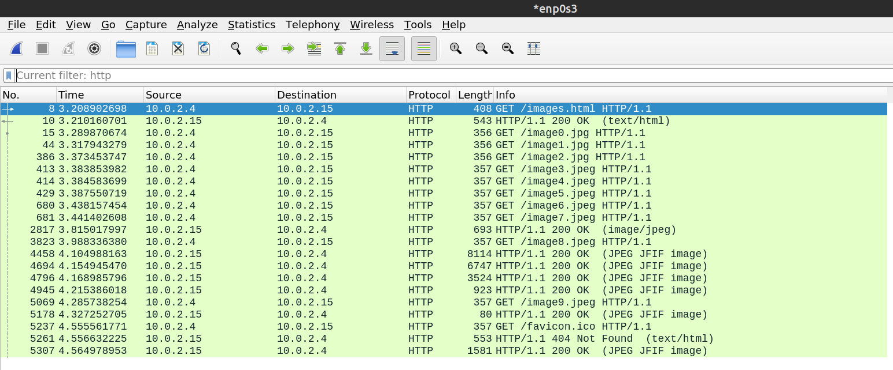

f) 10 persistent connections:

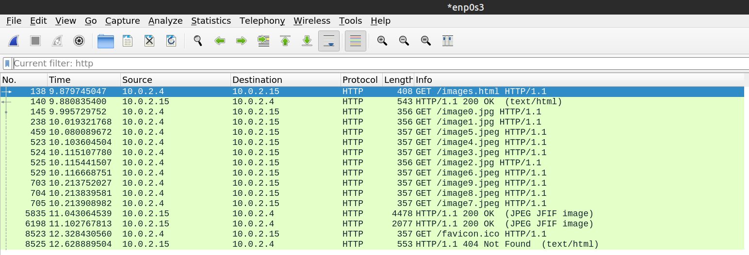

**Table:**

|  |  |
| --- | --- |
| **Connection Type** | **Time** |
| **Non-persistent connection** | 14.525030317 – 8.511104686 = **6.013925631** |
| **2 persistent connections** | 10.413480894 - 6.77849375 = **3.634987144** |
| **4 persistent connections** | 51.454647528 - 50.123384654 = **1.331262874** |
| **6 persistent connections** | 15.316624175 - 14.169158058 = **1.147466117** |
| **8 persistent connections** | 4.327252705 - 3.208902698 = **1.118350007** |
| **10 persistent connections** | 11.102767813 - 9.879745047 = **1.223022766** |

* **The best number of persistent connections is 6 or 8.**

------------------------------------------------------------

**Task 2:**

**Objectives:**

Understand working of HTTP headers:

Conditional Get: If-Modified-Since

HTTP Cookies: Cookie and Set-Cookie

Authentication: Auth-Basic

Design a web page that has one embedded page (e.g. image) and sets a cookie and enables authentication. You are required to configure the web server (e.g. apache) with authentication mechanism.

Show the behaviour of conditional get when embedded objects is modified and when it is not (you can just change the create date of the embedded object). Decode the Basic-Auth header using Base64 mechanism as per the password setup.

**1. Password Authentication:**

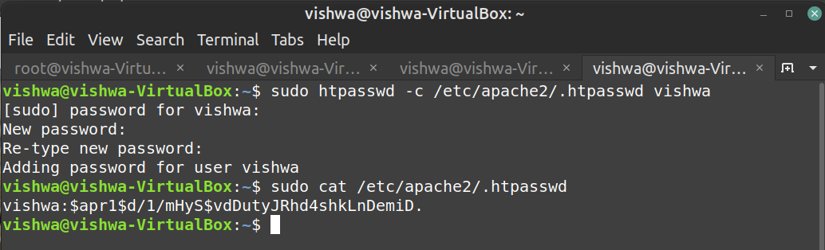

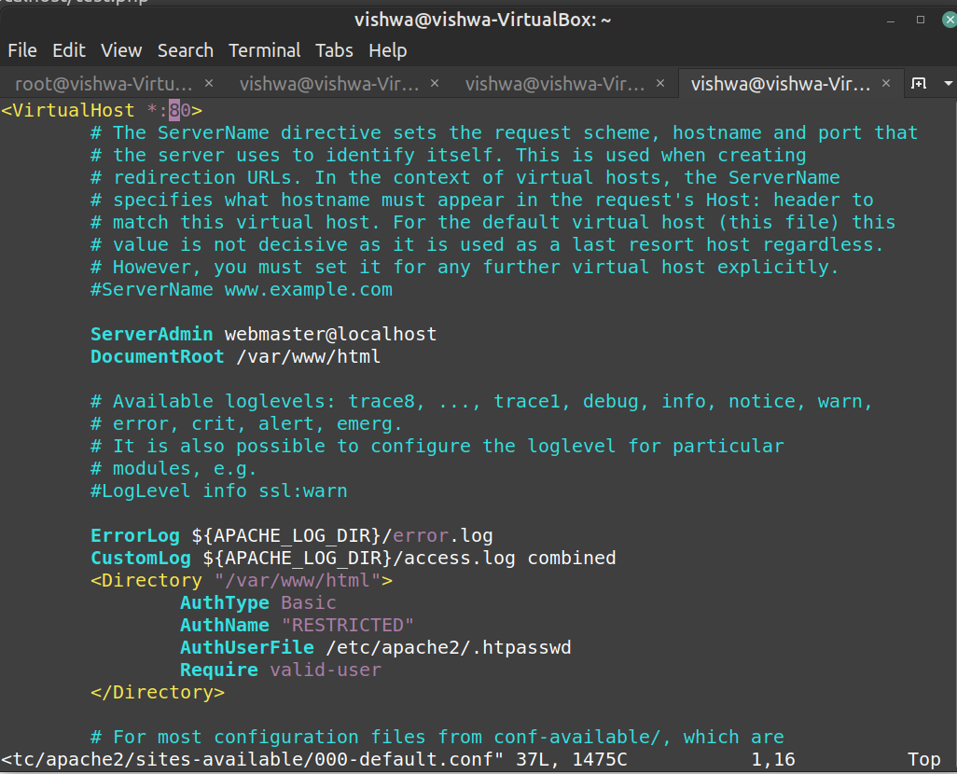

**OBSERVATIONS:**

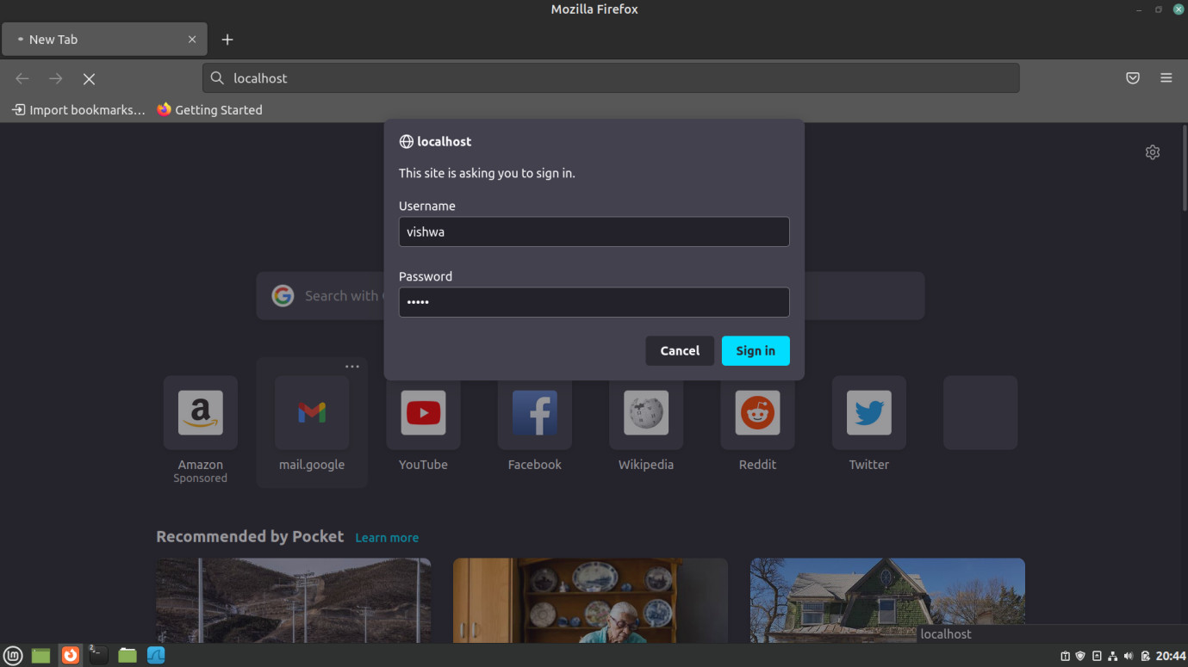

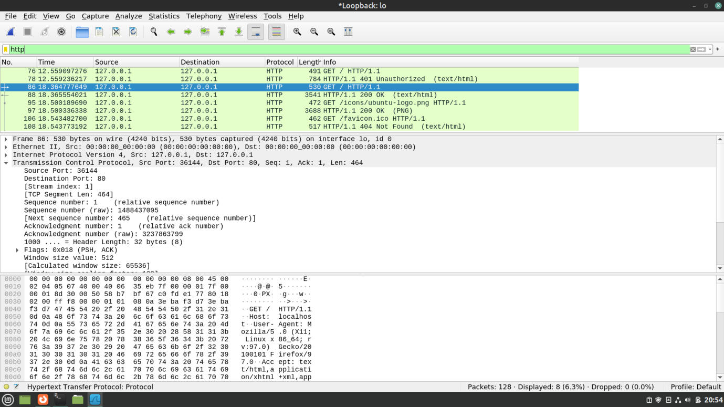

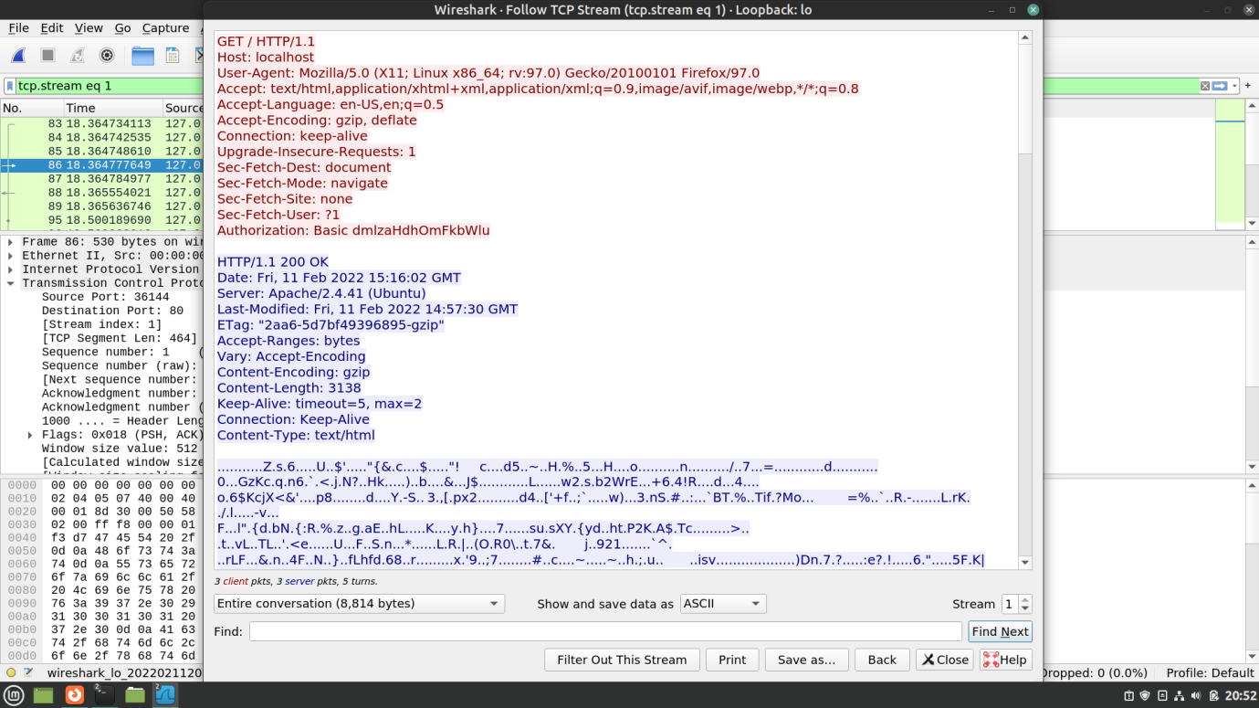

**Decoding the username and password:**

**“dmlzaHdhOmFkbWlu”** to Binary **6-bit** blocks:

011101 100110 100101 110011 011010 000111 011101 100001 001110 100110 000101 100100 011011 010110 100101 101110

**“dmlzaHdhOmFkbWlu”** to Binary with **8-bit** blocks:

01110110 01101001 01110011 01101000 01110111 01100001 00111010 01100001 01100100 01101101 01101001 01101110

8-bit blocks converted to **ASCII**:

**vishwa:admin**

Here, **vishwa** is the username and **admin** is the password.

**2. Cookie Setting:**

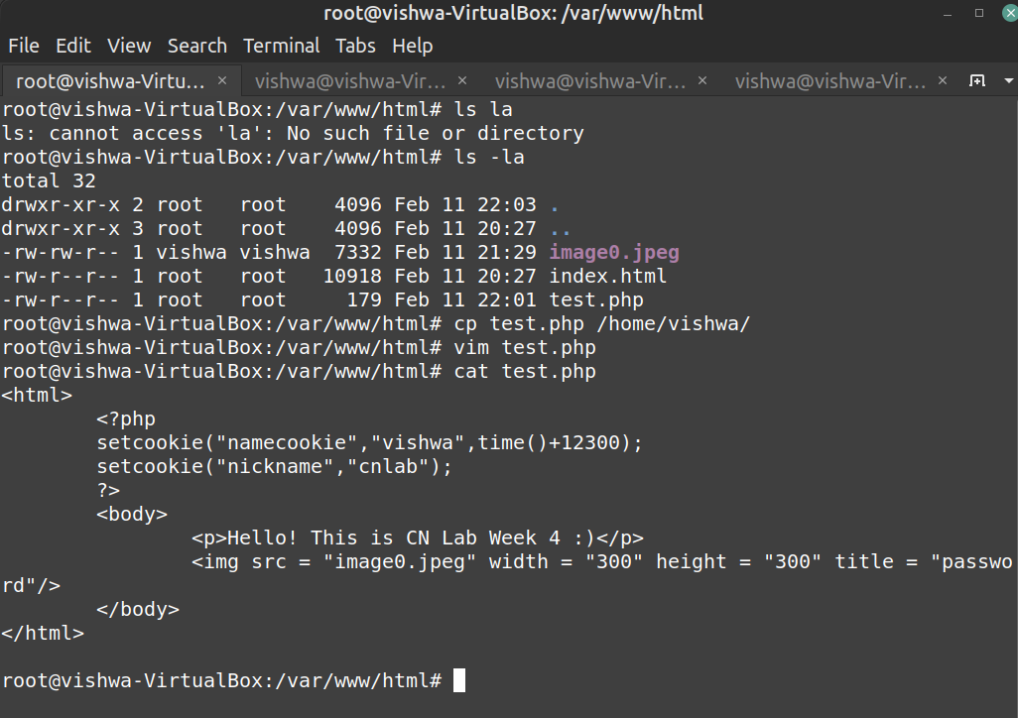

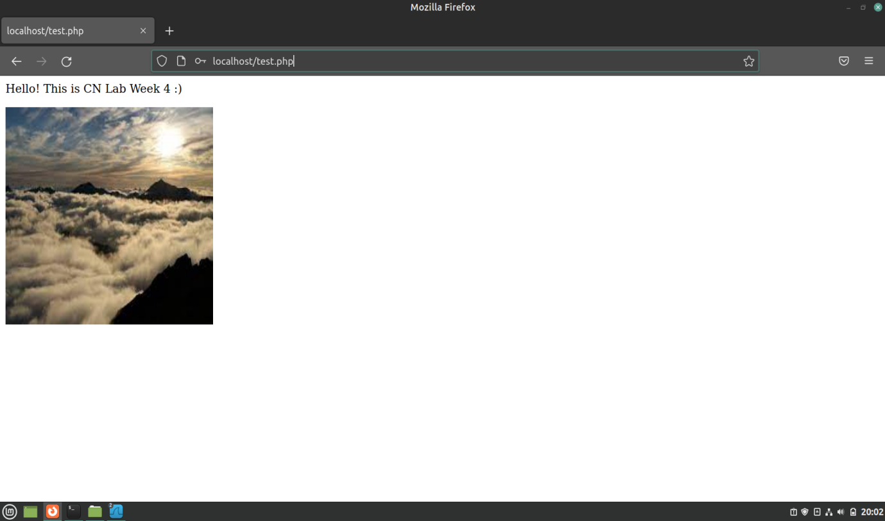

**OBSERVATIONS:**

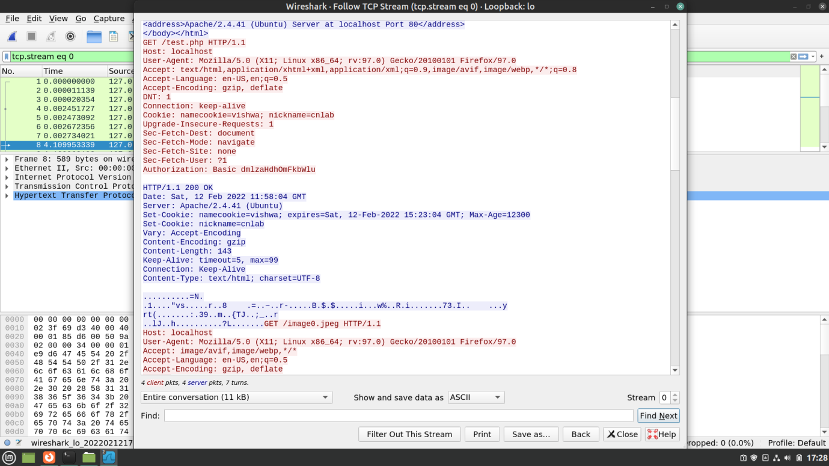

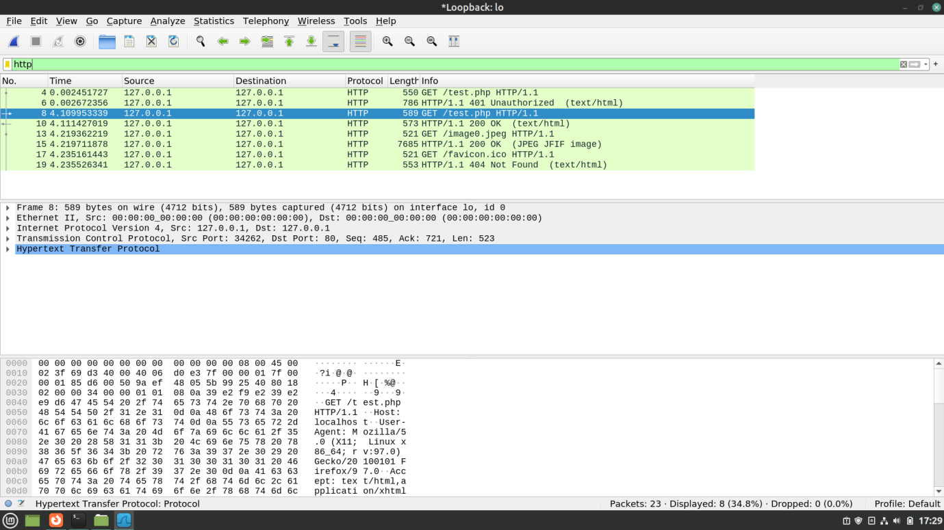

**3. Conditional get**:

**OBSERVATIONS:**

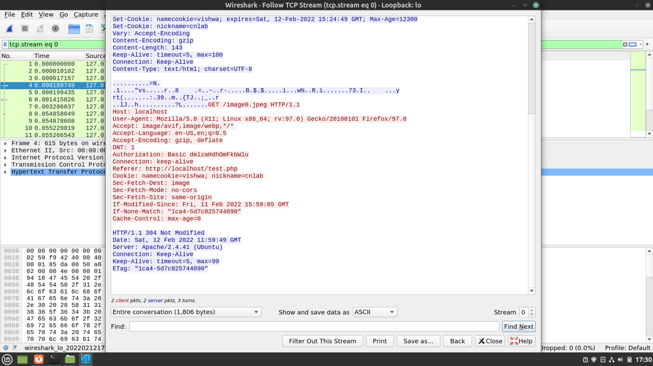

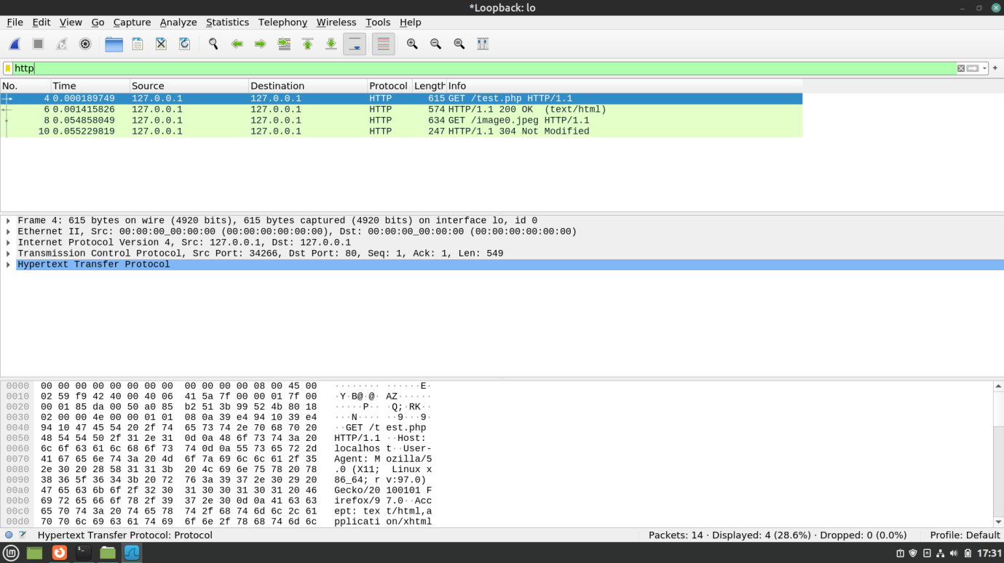

* **IF-MODIFIED-SINCE** line is not seen in the first HTTP Get request but seen in the second request followed by the **day, date and time of modification** **in the server**.
* The HTTP Status Code is **304 Not Modified.**